#include<iostream>

using namespace std;

enum CPU_Rank{P1=1,P2,P3,P4,P5,P6,P7};

class CPU{

public:

CPU();

void run(enum CPU_Rank rank,int frequency,float voltage);

void stop();

~CPU();

private:

enum CPU_Rank rank;

int frequency;

float voltage;

};

CPU::CPU(){

cout<<"构造函数"<<endl;

}

CPU::~CPU(){

cout<<"析构函数"<<endl;

}

void CPU::run(enum CPU_Rank rank,int frequency,float voltage){

cout<<"rank="<<rank<<" frequency="<<frequency<<"MHz voltage="<<voltage<<endl;

}

int main(){

CPU CPU1;

CPU1.run(P7,1,1.1);

return 0;

}

#include<iostream>

using namespace std;

class Computer{

public:

void run();

void stop();

private:

char cpu;

float ram;

char cdrom;

};

class CPU{

};

class RAM{

};

class CDROM{

};

int main(){

cout<<"emmmm"<<endl;

}

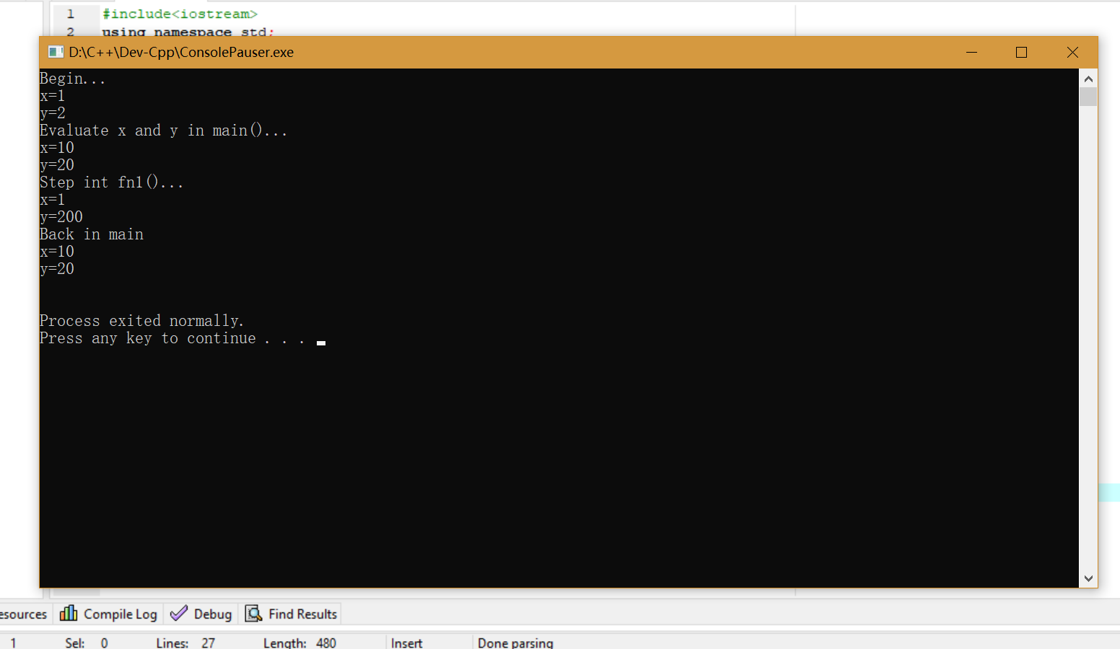

client.h头文件

#ifndef CLIENT_H

#define CLIENT_H

class CLIENT

{

public:

CLIENT();

~CLIENT();

};

#endif

client.cpp源文件

#include<iostream>

#include"client.h"

using namespace std;

CLIENT::CLIENT()

{

cout<<"CLIENT构造函数！"<<endl;

}

CLIENT::~CLIENT()

{

cout<<"CLIENT析构函数！"<<endl;

}

lab5_2源文件

#include<iostream>

#include"client.h"

using namespace std;

int main()

{

CLIENT client;

}